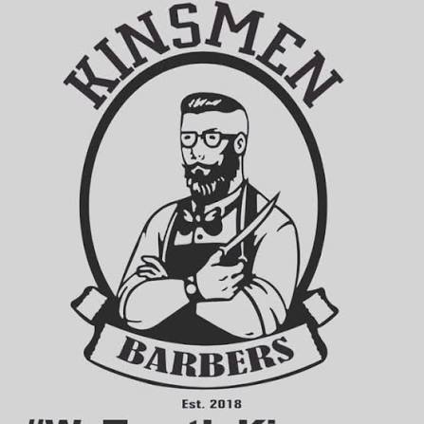
Client: Kinsmen
INSY7315
WORK INTEGRATED LEARNING
TASK 1: DOCUMENTATION
Team Name: Emerald Solutions
Team Members
Name | Student Number
Zario Di Paolo | ST10441349
Kaehil Indurjeeth | ST10438880
Kyra Naidoo | ST10448414
Gregory Luyckfasseel | ST10441344
Module: Information Systems 3E (Work Integrated Learning) — INSY7315
The Independent Institute of Education (IIE)

Table of Contents
Table of Contents 2
1. Introduction 5
2. Requirements 6
2.1 User Roles 6
2.2 User Stories 6
2.3 User Experience Journey Map 9
2.4 Work Breakdown Structure 10
3. Non-Functional Requirements 14
3.1 Performance 14
3.2 Scalability 14
3.3 Availability 14
3.4 Security 14
3.5 Usability 14
3.6 Reliability 15
3.7 Maintainability 15
3.8 Compatibility 15
4. Analysis Artifacts 16
4.1 Domain Modelling 16
Class descriptions 16
4.2 Design Artifacts 17
Key design notes 18
5. Implementation 19
5.1 Sequence Diagram — Create Booking 19
5.2 State Diagram — Booking Status 19
5.3 Deployment Plan 20
6. Data Schema 21
6.1 Choice of Technology 21
6.2 Entity Relationship Diagram 21
6.3 Schema Description 22
7. Architecture Artifacts 24
7.1 Design Patterns 24
7.1.1 Repository Pattern 24
7.1.2 Unit of Work Pattern 24
7.1.3 Factory Pattern 24
7.1.4 Strategy Pattern 24
7.1.5 Observer Pattern 25
7.2 Architecture Patterns 25
7.2.1 Model-View-Controller (MVC) 25
7.2.2 Layered (N-Tier) Architecture 26
7.3 Cloud Architecture 27
8. Security 28
8.1 Network Security 28
8.2 Authentication and Authorisation 28
8.3 Common Vulnerabilities and Mitigations 28
8.4 Cross-Site Scripting (XSS) Prevention 28
8.5 Data Protection 29
8.6 QR Code Implementation 29
8.7 Biometric Authentication (Future Consideration) 30
9. DevOps 31
9.1 Branching Strategy and Development Flow 31
9.2 Automated Testing 31
9.3 GitHub Actions Pipeline 31
10. Running Costs 33
10.1 Monthly Running Costs (Current Scale) 33
10.2 Cost at Scale 33
10.3 Two-Year Growth Projection 33
11. Change Management 35
11.1 Organisational Adoption 35
11.2 Customer Adoption 35
11.3 Handover and Transition Timeline 35
11.4 Future Enhancements 35
12. Prototype 36
12.1. GitHub pages hyperlink 36
References 37
Appendices 39
Annexure A – Declaration of Authenticity 39

1. Introduction
Kinsmen is a barbershop seeking a digital solution to modernise how customers book appointments and purchase in-shop products. Currently, bookings are managed manually, which limits the shop's capacity to plan barber schedules, track service demand, and offer customers a convenient, always-available booking channel.
This document sets out the requirements, design, and technical plan for the Kinsmen booking and shop system: a web application built on ASP.NET Core MVC, hosted on Microsoft Azure, and backed by an Azure SQL Database. The system allows customers to browse barbers and services, book appointments against real-time barber availability, leave reviews after a completed visit, and separately browse and add shop products to a cart, all combined into a single checkout that is settled in person at the shop.
The project is being developed by a four-person team — Kaehil, Kyra, Zario, and Gregory, trading as Emerald Solutions — as part of the INSY7315 Work Integrated Learning module. This document represents Task 1 of the module: the requirements, design, and initial project plan on which the working prototype and, later, the fully implemented system will be built.

2. Requirements

2.1 User Roles
The following user roles are drafted from the requirements and terminology already confirmed internally through team working sessions and from the team's working knowledge of the Kinsmen booking and shop system, to progress the documentation ahead of the deadline. This section is pending confirmation via the outstanding client questionnaire and will be revised if Kinsmen's response differs from the assumptions below.

Guest — an unregistered visitor who can browse the site's public content — services, barbers, and shop products — without creating an account. A Guest is prompted to register or log in only when attempting to complete a booking, add items to a cart at checkout, or leave a review.

Customer — a registered user who books appointments, purchases shop products, manages their own booking history, and leaves reviews after a completed visit. This is the primary consumer-facing role for the Kinsmen system.

Barber — a Kinsmen staff member who performs services for customers. A Barber can view their own schedule, mark time slots as blocked (e.g. for breaks or days off), and update the status of their own bookings. A Barber does not manage other barbers' schedules or shop administration.

Admin — Kinsmen management, responsible for overall system administration: managing services and products, updating pricing and stock levels, managing barber profiles, and viewing bookings across the shop. This role reflects the single-branch, single-admin-team structure confirmed with the client to date.

2.2 User Stories
The user stories below are drafted from the same confirmed requirements and team decisions referenced in Section 2.1, to progress the documentation ahead of the deadline. They are pending confirmation via the outstanding client questionnaire and will be revised or extended once Kinsmen's response is received.

Guest
- As a Guest browsing the site, I want to view the list of services and their prices, so that I can decide whether to book without creating an account.
- As a Guest browsing the site, I want to view barber profiles and bios, so that I can choose a barber I like before registering.
- As a Guest browsing the shop, I want to view products and prices, so that I can plan a purchase before committing to an account.
- As a Guest ready to book or check out, I want to be prompted to register or log in only at that point, so that I am not forced to create an account just to browse.
Customer
- As a Customer booking an appointment, I want to select multiple services in one booking, so that I can get a haircut and beard trim in the same visit.
- As a Customer booking an appointment, I want to choose a specific barber or “any available barber”, so that I can book with someone I trust or get the earliest available slot.
- As a Customer booking an appointment, I want to see only time slots the chosen barber is available for, so that I do not attempt to book a time that is already taken or blocked.
- As a Customer with an upcoming booking, I want to view, reschedule, or cancel my booking from my account, so that I can manage my own plans without contacting the shop directly.
- As a Customer who has completed a visit, I want to leave a rating and comment, so that I can share my experience and help other customers choose.
- As a Customer browsing the shop, I want to add multiple products to a cart and check out alongside my booking, so that I can pay for everything in a single in-person transaction.
- As a Customer, I want to receive an email confirmation when my booking is made, so that I have a record of my appointment details.
Barber
- As a Barber, I want to view my own schedule for the day or week, so that I know which appointments I have coming up.
- As a Barber, I want to block out time on my schedule, so that customers cannot book me during breaks or days off.
- As a Barber, I want to update the status of a booking (e.g. mark as completed or no-show), so that the system accurately reflects what happened.
- As a Barber, I want to view the services and any notes attached to an upcoming booking, so that I can prepare for the appointment.
Admin
- As an Admin, I want to add, edit, or deactivate services and their prices, so that the site always reflects what Kinsmen currently offers.
- As an Admin, I want to add, edit, or deactivate shop products and update stock levels, so that customers cannot purchase items that are out of stock.
- As an Admin, I want to add or update barber profiles, so that new staff can appear on the booking site and inactive staff can be hidden.
- As an Admin, I want to view all bookings across every barber, so that I can manage the shop's overall schedule and spot conflicts.

2.3 User Experience Journey Map
The journey map below is presented as a screen-navigation table, listing each screen, how it is reached, and where it leads, for each user role. It is drafted from the confirmed requirements and design decisions referenced in Sections 2.1–2.2 to progress the documentation ahead of the deadline and is pending confirmation via the outstanding client questionnaire. It will be aligned with the visual prototype (submitted separately per the module manual) once finalised.

Guest & Customer Journey
Screen | Accessible From | Leads To
Home | Entry point | Services, Barbers, Shop, Login/Register
Browse Services | Home, nav bar | Service Detail, Booking: Select Barber
Browse Barbers | Home, nav bar | Barber Profile, Booking: Select Service(s)
Booking: Select Service(s) | Browse Services, Barber Profile | Booking: Select Barber
Booking: Select Barber | Booking: Select Service(s) | Booking: Select Date/Time
Booking: Select Date/Time | Booking: Select Barber | Booking: Confirmation (login prompt if Guest)
Booking: Confirmation | Booking: Select Date/Time | My Bookings, Home
Login/Register | Home, Booking Confirmation, Checkout | My Account, returns to originating flow
My Account / My Bookings | Login, nav bar | Booking Detail (reschedule/cancel), Leave Review
Leave Review | My Bookings (post-visit) | My Bookings
Shop (browse products) | Home, nav bar | Product Detail, Cart
Cart | Product Detail, nav bar | Checkout
Checkout | Cart, Booking Confirmation | Order Confirmation
Order Confirmation | Checkout | My Account, Home

Barber Journey
Screen | Accessible From | Leads To
Barber Login | Home | Barber Dashboard (Schedule)
Barber Dashboard (Schedule) | Barber Login | Booking Detail, Block Time
Block Time | Barber Dashboard | Barber Dashboard (updated)
Booking Detail (Barber view) | Barber Dashboard | Update Status

Admin Journey
Screen | Accessible From | Leads To
Admin Login | Home | Admin Dashboard
Admin Dashboard | Admin Login | Manage Services, Manage Products, Manage Barbers, All Bookings
Manage Services | Admin Dashboard | Add/Edit Service
Manage Products | Admin Dashboard | Add/Edit Product
Manage Barbers | Admin Dashboard | Add/Edit Barber Profile
All Bookings (Admin view) | Admin Dashboard | Booking Detail

2.4 Work Breakdown Structure
The table below breaks the Kinsmen project down into tasks spanning the full development lifecycle, from initial requirements gathering through to the Task 3 EXPO submission. Durations are estimates based on the team's confirmed 4-session plan leading into Task 1, and on the submission, dates set out in the module manual.
Task | Description | Duration | Predecessor(s) | Owner(s) | Resources
Send & collect client questionnaire | Gather Kinsmen's business needs, services, and preferences | 5 days | None | Kaehil (sent), all (review) | Questionnaire document, email
Confirm tech stack & architecture | Team decision on MVC, SQL Server, Azure, branching strategy | 1 day | None | All | Meeting time
GitHub repository & pipeline setup | Initialise repo, branch protection rules, initial CI/CD skeleton | 2 days | Tech stack confirmed | Kaehil | GitHub, GitHub Actions
Domain modelling & ERD | Define entities, attributes, and relationships | 3 days | Client requirements received | Zario (Kaehil support) | Diagramming tool, requirements doc
Design class diagram | Translate domain model into implementation-level classes | 2 days | Domain model complete | Zario | UML tool
UX journey map & prototype | Map user flows and screens; build HTML prototype | 5 days | Requirements gathered | Gregory | HTML/CSS, design assets
Architecture & security write-up | Document architecture pattern, design patterns, cloud architecture, security | 3 days | Domain model, tech stack confirmed | Kyra (patterns/security), Zario (architecture), Kaehil (cloud) | Research articles, PRSE notes
DevOps & running costs documentation | Document GitHub workflow, CI/CD pipeline, cost projections | 2 days | GitHub setup complete | Kaehil (DevOps), Kyra (costs) | Azure pricing calculator
Compile & finalise Task 1 documentation | Merge all sections into one PDF, format, proofread | 2 days | All Task 1 sections complete | Kaehil (Gregory support) | Word/PDF tools
Submit Task 1 | Upload documentation and prototype link to ARC | 1 day | Documentation finalised | One team member | ARC portal — due 17 Aug 2026
Database implementation | Build SQL Server schema from ERD, seed test data | 4 days | Task 1 submitted | Kaehil (Zario support) | SQL Server, Azure SQL
Backend API development | Build booking, service, barber, and customer endpoints | 10 days | Database implemented | Zario (Kaehil, Kyra support) | ASP.NET Core, Visual Studio
Front-end development | Build MVC views for booking flow, barber profiles, multi-service selection | 10 days | UX journey map, backend API skeleton | Gregory (Zario support) | HTML/CSS/Bootstrap, Razor views
Automated testing | Unit and integration tests for booking logic and APIs | 5 days | Backend API in progress | Kyra | xUnit, GitHub Actions
CI/CD pipeline completion | Finalise build/test/deploy automation | 3 days | Testing framework in place | Kaehil | GitHub Actions, Azure App Service
Hosting & deployment | Deploy application and database to Azure | 2 days | CI/CD pipeline complete | Kaehil | Azure App Service, Azure SQL
Implementation presentation prep | Prepare demo, slides, technical walkthrough | 2 days | Application hosted and functional | All (Kaehil, Gregory lead) | PowerPoint, live demo environment
Submit Task 2 | Submit GitHub link and README on ARC | 1 day | Presentation prep complete | One team member | ARC portal — due 28 Sept 2026
Final report update & polish | Incorporate Task 1 & 2 feedback into one combined document | 4 days | Task 2 feedback received | Kaehil (all contribute) | Word/PDF tools
User guide creation | Write step-by-step user guide with screenshots | 3 days | Application feature-complete | Kyra (Gregory screenshots) | Screenshot tool, Word
Final bug fixes & polish | Resolve outstanding issues, refine UI/UX | 5 days | Task 2 submitted | Zario, Gregory (Kaehil support) | Visual Studio, Azure
EXPO preparation | Prepare exhibit board, slides, demo script, Q&A prep | 3 days | Application finalised | All | Poster/board materials, PowerPoint
Submit Task 3 | Individual submission of final documentation, user guide, annexures | 1 day | EXPO preparation complete | All (individual) | ARC portal — due Exam Week 1 (TBC)

3. Non-Functional Requirements

3.1 Performance
- The system shall return booking availability results (barber/time slot lookups) within 2 seconds under normal load, given the small dataset size expected for a single-branch shop.
- Page load times for customer-facing views (booking, service browsing, shop) shall not exceed 3 seconds on a standard broadband or mobile connection.

3.2 Scalability
- The system shall support scaling from an estimated 100 users at launch to 10,000 users without requiring a change in underlying architecture, in line with the tiered growth path set out in Section 10.2.
- The Azure App Service and Azure SQL Database tiers shall be upgradeable independently of one another, consistent with the tier progression already documented in Running Costs.

3.3 Availability
- The system shall target 99.5% uptime during business hours, reflecting Azure App Service’s standard managed-service reliability rather than a custom high-availability configuration, which is not justified at the current single-branch scale (Section 7.3).
- Planned maintenance or deployments shall occur outside of the shop’s operating hours where possible, to minimise disruption to customer bookings.

3.4 Security
- All data in transit shall be encrypted via HTTPS/TLS, and all data at rest shall be encrypted via Azure SQL’s Transparent Data Encryption, as detailed in Section 8.
- User passwords shall never be stored in plain text, and authentication shall be role-based, distinguishing Customer, Barber, Admin, and Guest access levels once roles are finalised (Section 2.1).
- The system shall be protected against common web vulnerabilities, including SQL injection, XSS, and CSRF, as detailed in Section 8.3–8.4.

3.5 Usability
- The booking flow shall be completable by a first-time user in no more than five steps (service selection, barber selection, time slot choice, confirmation, and submission).
- The system shall be responsive and fully functional on both desktop and mobile browsers, given that customers are expected to book primarily via mobile devices, including via the shopfront QR code.

3.6 Reliability
- The system shall prevent double-booking of a barber for overlapping time slots at the database level, enforced through the TimeSlot validation logic described in Section 6.3.
- Automated tests (Section 9.2) shall cover core booking and checkout logic, and no code shall be deployed to production without passing the full automated test suite.

3.7 Maintainability
- The codebase shall follow the layered architecture and design patterns set out in Section 7, allowing individual layers (presentation, business logic, data access) to be modified independently.
- All infrastructure and configuration changes shall be applied through the GitHub Actions CI/CD pipeline rather than manual changes to the production environment, ensuring changes are tracked and reproducible.

3.8 Compatibility
- The system shall support the current and prior major versions of major browsers (Chrome, Safari, Edge, Firefox).
- The system shall not require any browser plugin or extension to function, including for the QR code and any future biometric login functionality.

4. Analysis Artifacts

4.1 Domain Modelling
The domain model below represents the core concepts of the Kinsmen system: the appointment booking flow (including barber time-slot availability and post-visit reviews) and the in-app shop, where customers can browse products, add them to a cart, and combine them with their booking(s) at a final checkout — paid in person at the shop (no online payment gateway is in scope). This reflects the domain model confirmed with the team on 30 July 2026, extended with the shop feature.
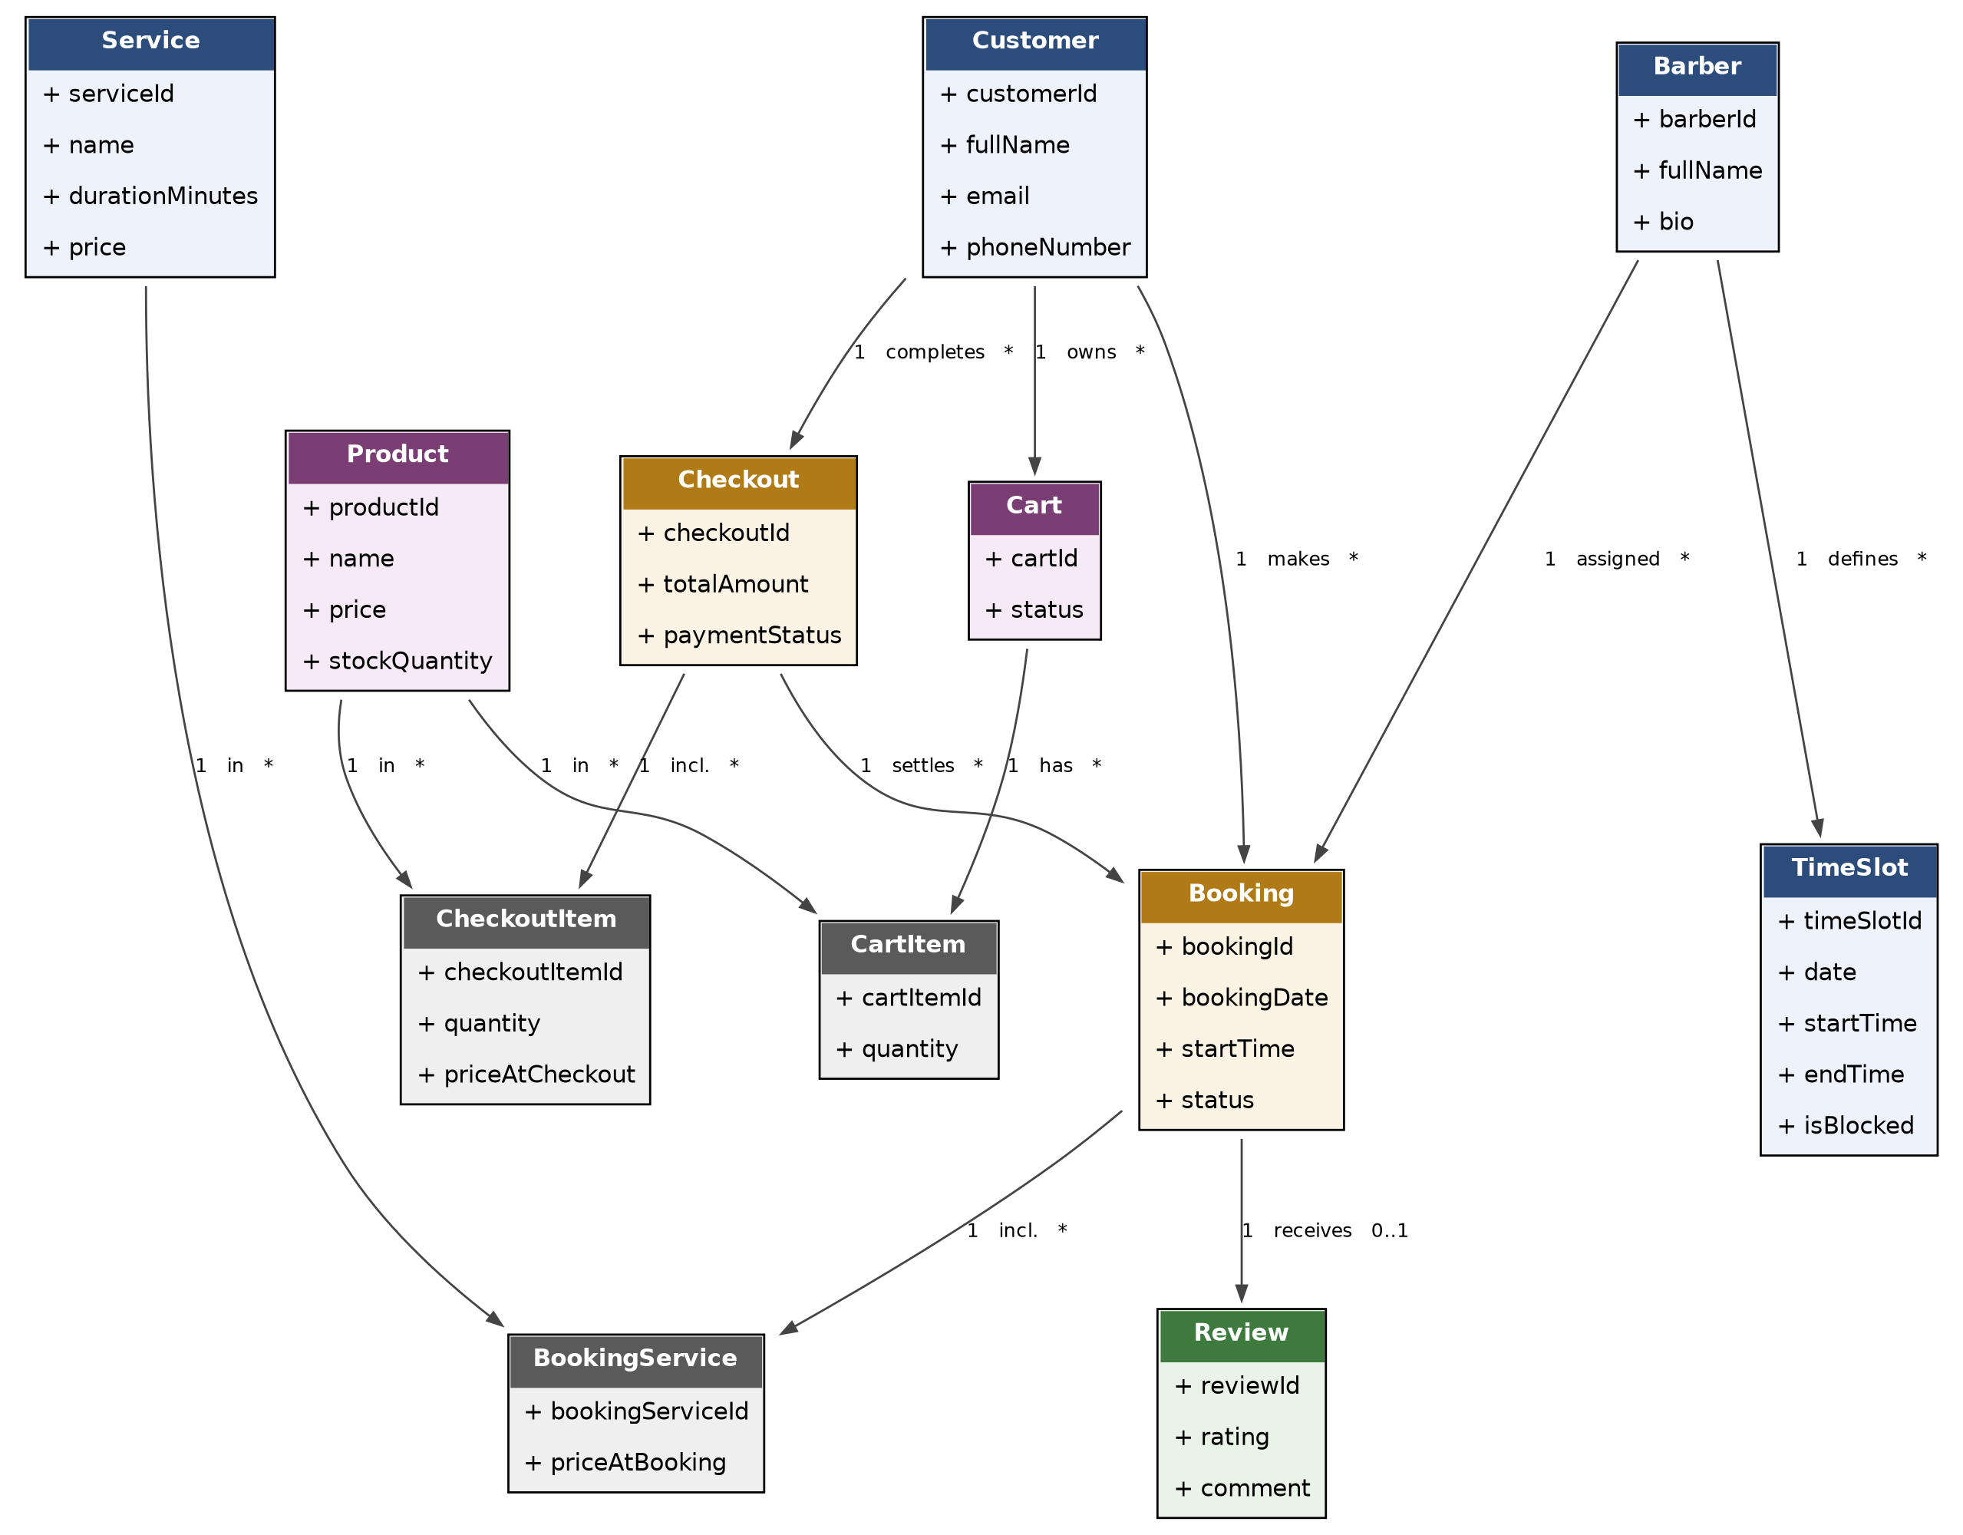
Figure 1: Domain class diagram — Kinsmen booking & shop system

Class descriptions
Customer — represents the person booking an appointment and/or shopping. Holds the contact details (email, phone number) required to send booking confirmations and reminders.
Barber — represents a staff member who performs services for customers, with a bio shown during barber selection.
Service — represents a bookable offering, such as a haircut or beard trim, with an associated duration and price.
TimeSlot — represents a barber's defined availability or a blocked period (e.g. a break or day off), used to validate that a requested booking time is available.
Booking — the central appointment transaction. Links a customer and a barber to a specific date and time, and tracks the booking's status (e.g. confirmed, completed, cancelled).
BookingService — a junction class resolving the many-to-many relationship between Booking and Service, since a single booking may include more than one service (e.g. a haircut and a beard trim in the same visit).
Review — an optional record a customer can leave after a completed booking, capturing a rating and comment on their experience.
Product — represents a physical item sold in the Kinsmen shop (e.g. grooming products), including its price and stock level.
Cart — represents a customer's in-progress shop selection prior to checkout.
CartItem — a junction class resolving the many-to-many relationship between Cart and Product, recording the quantity of each product added.
Checkout — represents the final transaction: it settles a customer's shop purchase together with their booking(s) into a single total, paid in person at the shop.
CheckoutItem — a junction class resolving the many-to-many relationship between Checkout and Product, storing the price of each product at the time of purchase — mirroring the same historical-accuracy pattern BookingService uses for services.
Note: the loyalty/points system discussed by the team is intentionally excluded from this domain model, as it is flagged for future implementation (see Change Management).

4.2 Design Artifacts
The design class diagram below extends the domain model with implementation-level detail: attribute data types, primary/foreign keys, access specifiers, and the operations each class exposes. Attributes are private (-) and exposed through public (+) methods, following standard encapsulation practice; Booking.UpdateStatus() is marked protected (#) since status transitions should only be triggered internally (e.g. by CancelBooking() or the checkout process) rather than set directly from outside the class. Naming follows PascalCase to match the C# implementation and the ERD in Section 6.
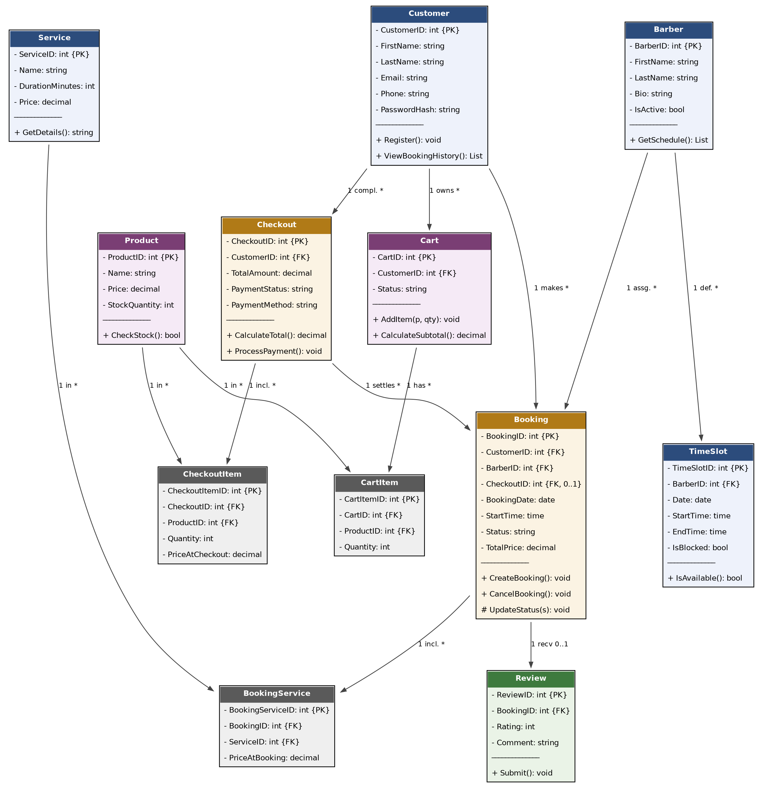
Figure 2: Design class diagram — Kinsmen booking & shop system

Key design notes
Keys: primary keys (PK) uniquely identify each record; foreign keys (FK) on Booking, BookingService, TimeSlot, Review, Cart, CartItem, Checkout and CheckoutItem implement the relationships shown in the domain model, matching the ERD foreign key constraints exactly (Section 6.2).
Encapsulation: all attributes are private, accessed only via the class's own public methods, protecting internal state from direct external modification.
Checkout.ProcessPayment() records that payment was taken in person at the shop and updates PaymentStatus accordingly — it does not integrate with an external payment gateway, in line with the current project scope.

5. Implementation

5.1 Sequence Diagram — Create Booking
The sequence diagram below documents the critical booking flow: a customer selects a service, barber, date and time; the system checks barber availability; and, if available, the booking is created and a confirmation is sent via the customer's chosen channel (email or WhatsApp, as agreed with the client). If the barber is not available, the system offers alternative time slots instead of creating the booking.
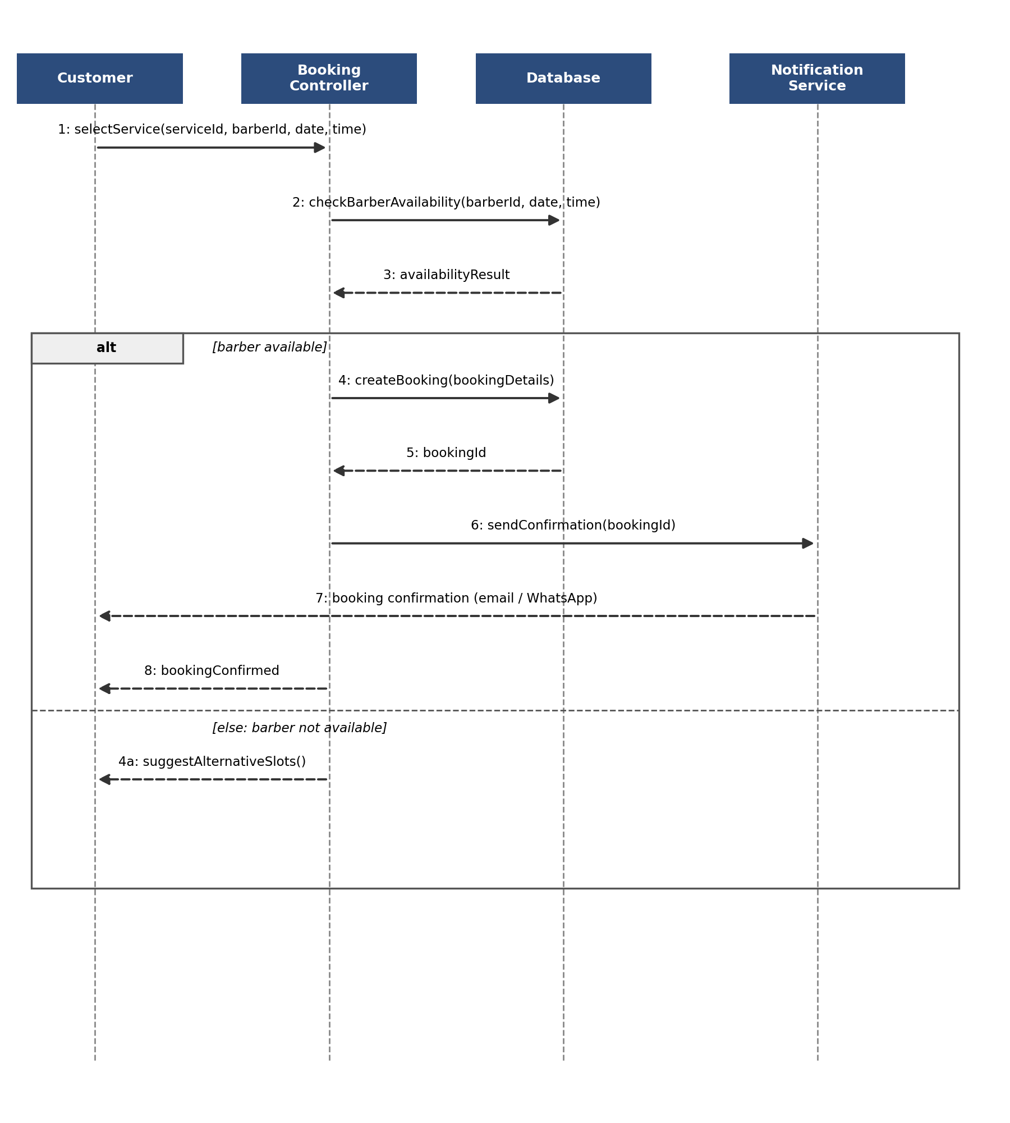
Figure 3: Sequence diagram — Create Booking

5.2 State Diagram — Booking Status
The state diagram below shows the lifecycle of a Booking's status attribute. A booking starts as Pending once submitted by the customer, moves to Confirmed once the barber/system confirms availability, and ends in one of three terminal states: Completed (the service was delivered), Cancelled (cancelled by either party, at any stage before completion), or No-Show (the customer did not arrive for a Confirmed booking).
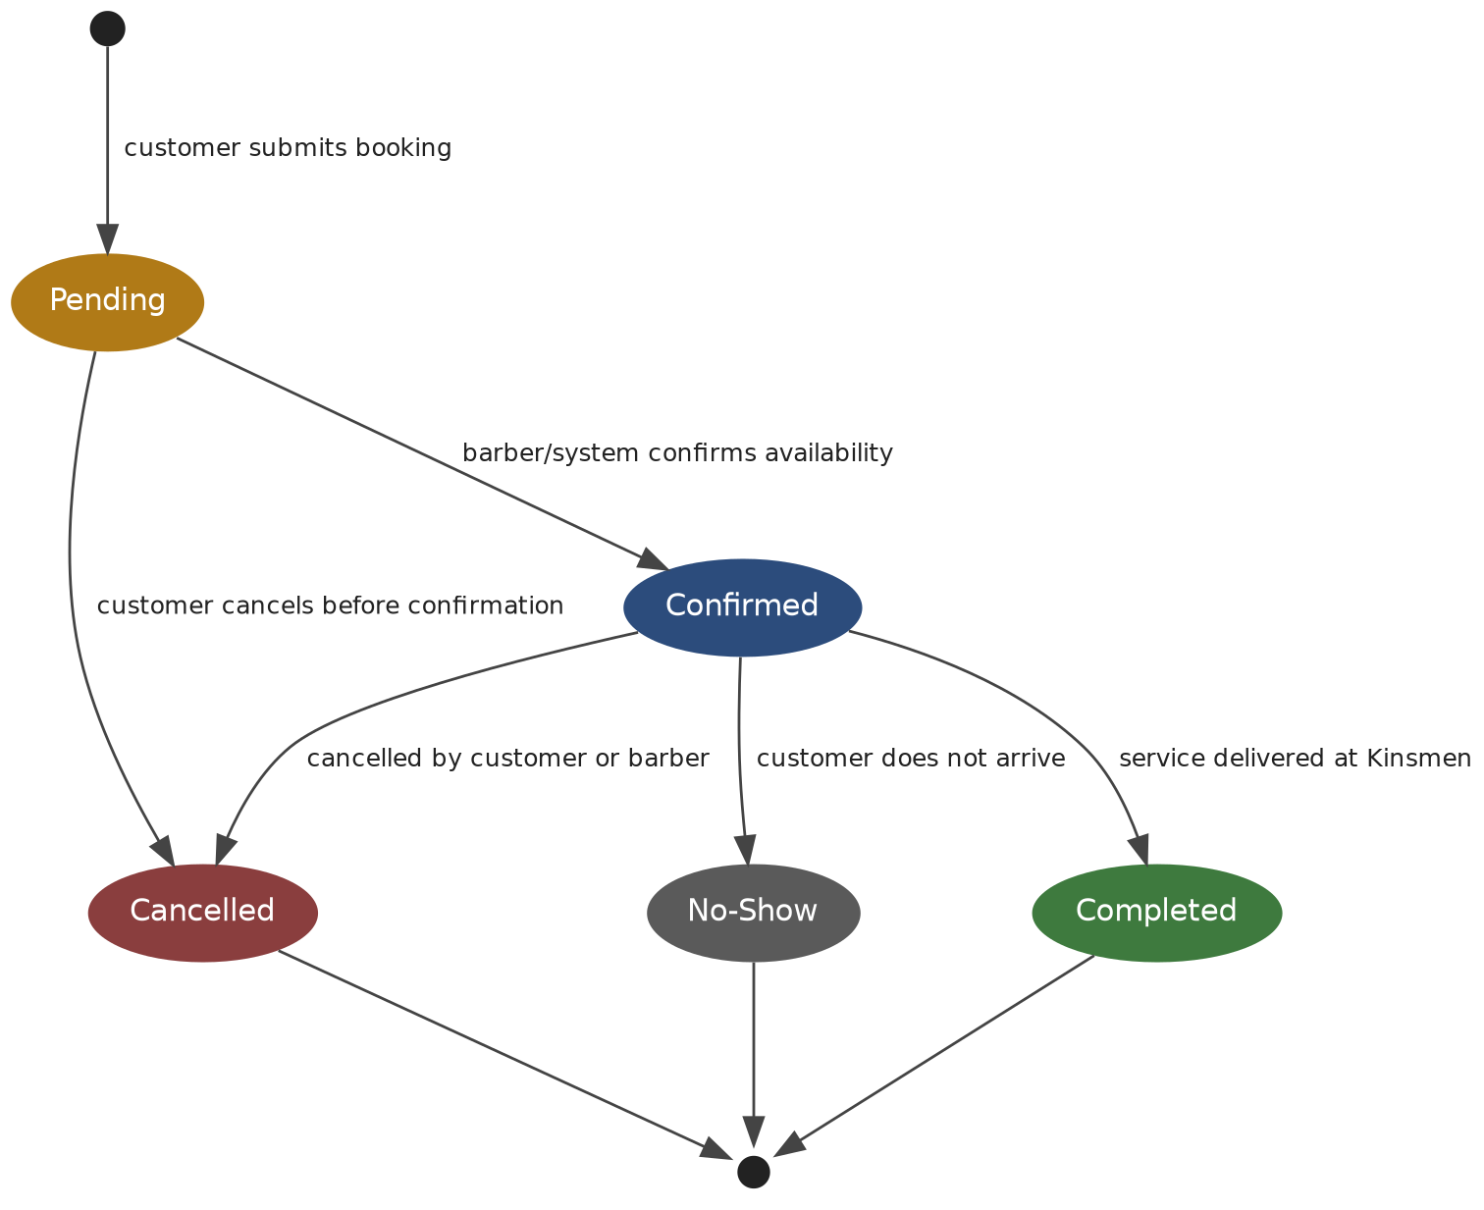
Figure 4: State diagram — Booking status lifecycle

5.3 Deployment Plan
The Kinsmen system is deployed to Microsoft Azure using the environment and pipeline already described in Section 9 (DevOps). At this stage of the project, the plan is intentionally simple, reflecting a single-branch production environment appropriate to the project's current scope; it will be revisited as the system matures through Task 2.
Provisioning: an Azure Resource Group is created to contain all Kinsmen resources, followed by an Azure App Service (Basic B1 tier) for the web application and an Azure SQL Database for data storage.
Configuration: the database connection string and any third-party API keys (e.g. the email notification provider) are stored in Azure App Service's Application Settings, not in source control, consistent with Section 8.1.
Schema deployment: Entity Framework Core migrations are applied automatically as part of the CD pipeline (Section 9.3), so the database schema always matches the deployed code version.
Release: once a pull request is merged to main, GitHub Actions builds, publishes, and deploys the application directly to the live App Service — there is currently no separate staging slot, given the team's size and timeline; this is a candidate improvement for Task 2.
Rollback: Azure App Service retains previous deployments, allowing the team to redeploy an earlier build manually if a release introduces a critical issue.

6. Data Schema

6.1 Choice of Technology
The Kinsmen booking system uses Microsoft SQL Server, hosted as an Azure SQL Database, as its primary data store. This choice was made for several reasons:
Relational structure fits the domain naturally — bookings, barbers, customers, and services have clearly defined relationships (including a many-to-many relationship between bookings and services) that map cleanly onto normalised relational tables.
ACID compliance is important for a scheduling system, where two customers must never be able to book the same barber for overlapping time slots.
Native integration with ASP.NET Core via Entity Framework Core reduces boilerplate data-access code and allows the schema to be version-controlled through code-first migrations.
Azure SQL Database is a fully managed service, which reduces the DevOps overhead of patching and maintaining a database server — important for a small team with a tight timeline.
The team has prior experience with SQL Server and Entity Framework Core from the GLMS project, reducing the learning curve during implementation.
Azure SQL offers a free-tier allowance suitable for a student project of this scale, keeping running costs low while the system is in development and early production use.

6.2 Entity Relationship Diagram
The ERD below extends the originally confirmed booking schema (Customer, Barber, Service, Booking, BookingService, TimeSlot, Review) with the shop feature (Product, Cart, CartItem, Checkout, CheckoutItem). The shop tables mirror the price-snapshot pattern already used by BookingService — CheckoutItem stores PriceAtCheckout so historical purchases remain accurate even if product prices change later, exactly as PriceAtBooking does for services.
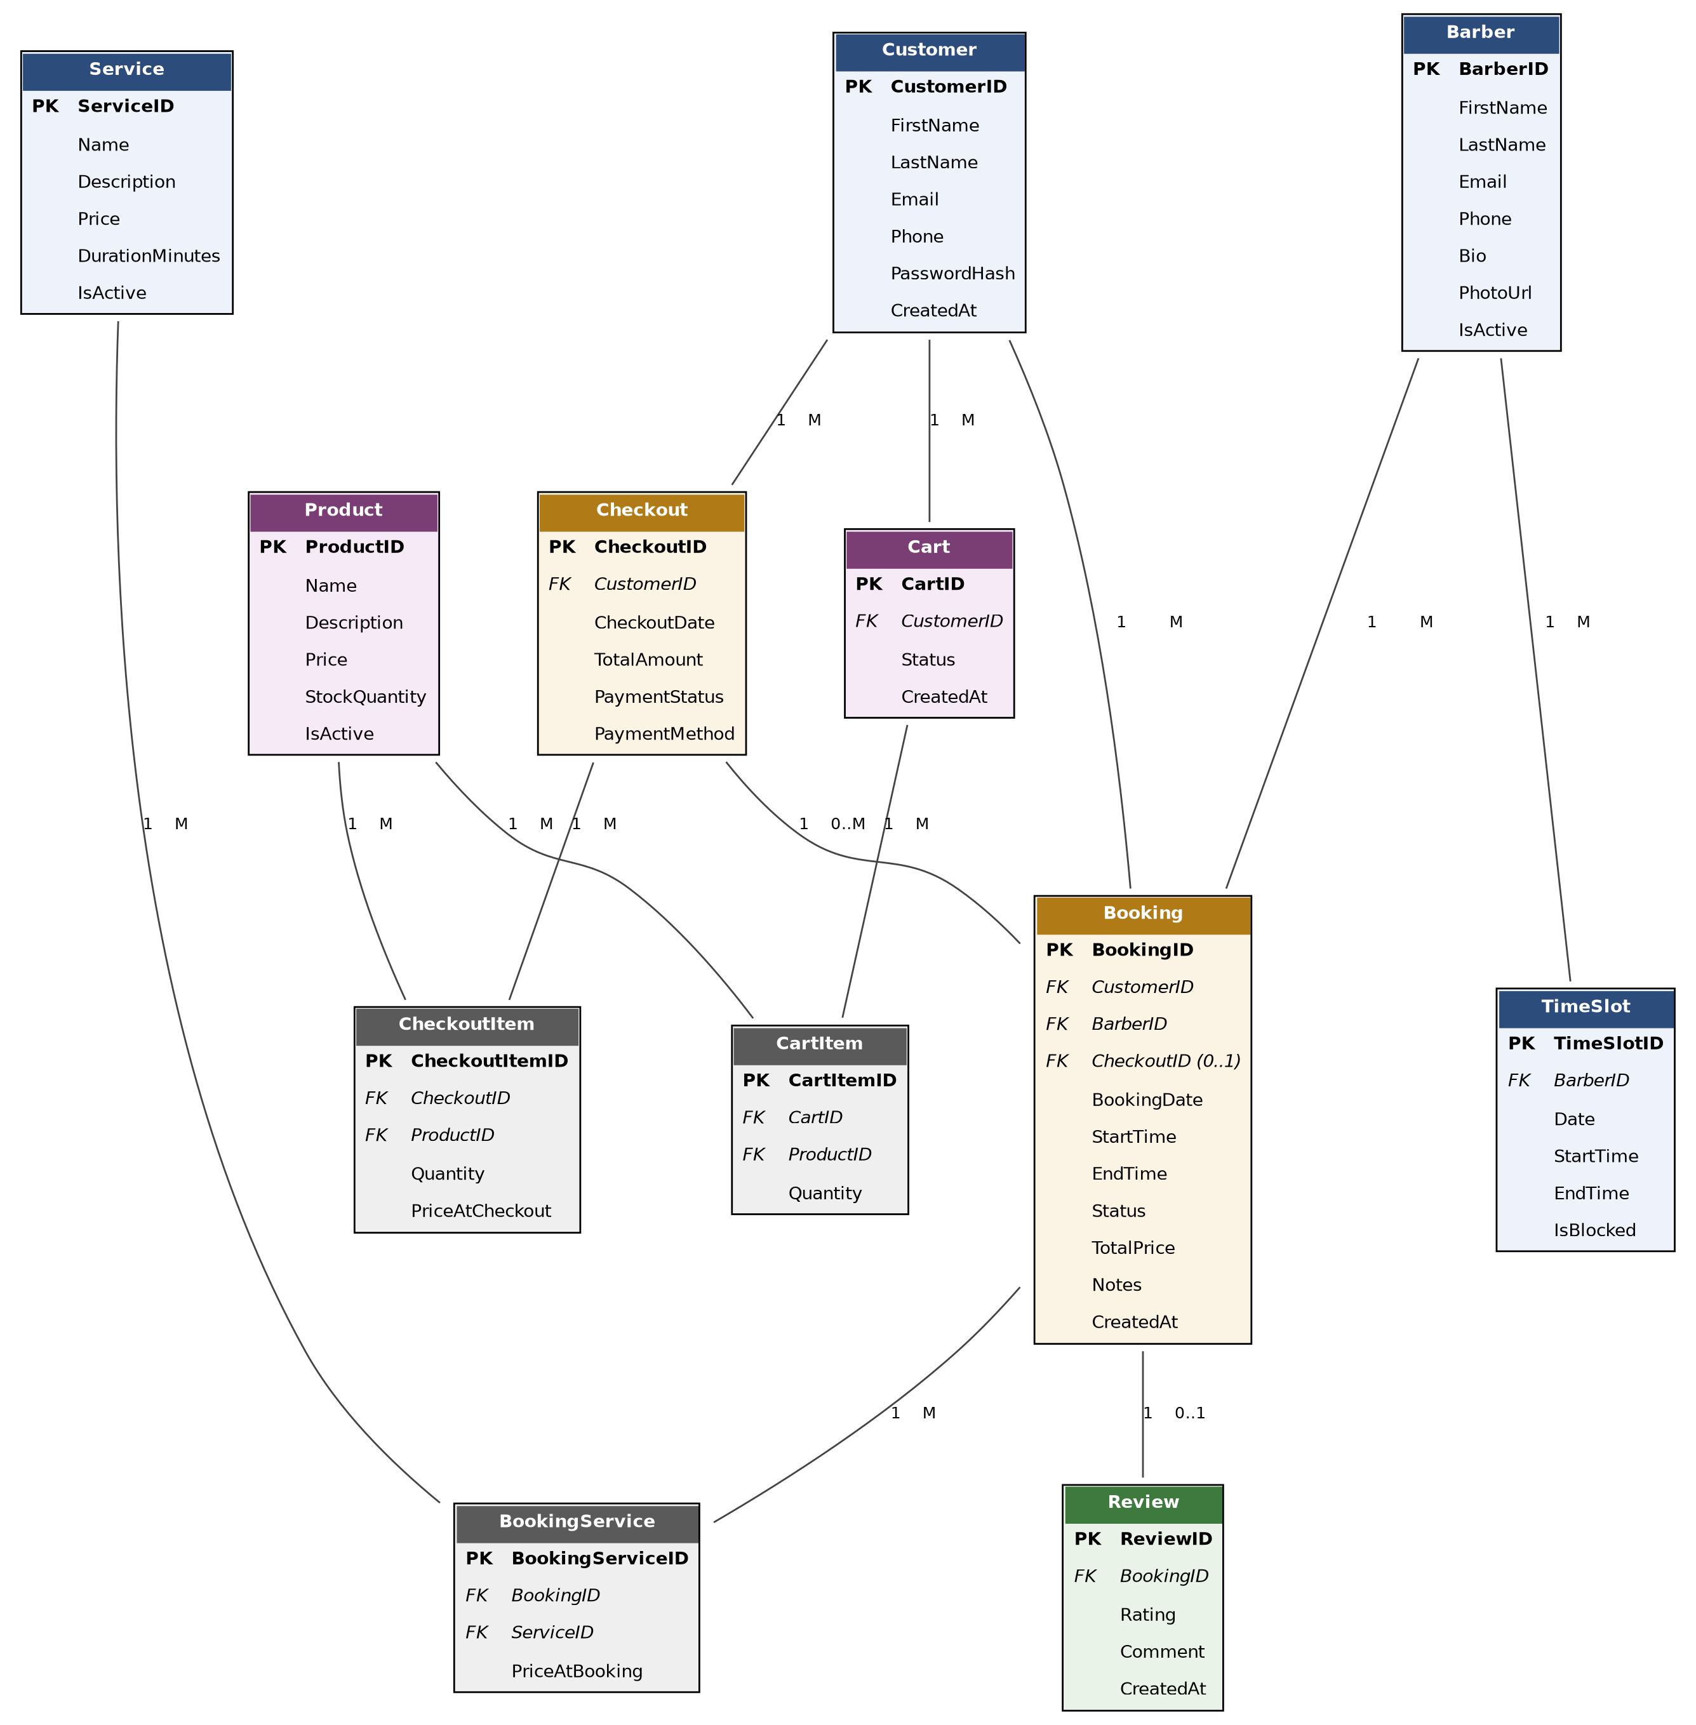
Figure 5: Entity Relationship Diagram — Kinsmen booking & shop system

6.3 Schema Description
Customer — stores customer account details used to make and manage bookings and shop purchases.
Barber — stores barber profile details, including bio and active status, used for barber selection during booking.
Service — stores each service offered (e.g. haircut, beard trim), including price and duration.
Booking — the central booking entity, linking one customer and one barber to a scheduled appointment. Stores computed totals (price, duration) and status (e.g. Pending, Confirmed, Cancelled, Completed), and optionally links to the Checkout that settled it.
BookingService — a junction table resolving the many-to-many relationship between Booking and Service, since a single booking can include multiple services. Stores the price of each service at the time of booking, so historical bookings remain accurate even if service prices change later.
TimeSlot — stores each barber's defined availability and blocked periods (e.g. breaks, days off), used to validate that a requested booking time is available.
Review — an optional record linked to a completed booking, allowing a customer to rate and comment on their experience.
Product — stores each item sold in the Kinsmen shop, including price and stock level.
Cart — a customer's in-progress shop selection prior to checkout, tracked via a Status field (e.g. Active, Abandoned, CheckedOut).
CartItem — a junction table resolving the many-to-many relationship between Cart and Product, recording the quantity of each product added.
Checkout — the final transaction settling a customer's shop purchase and/or one or more bookings, recording how payment was taken (PaymentMethod — in person at the shop, per current scope).
CheckoutItem — a junction table resolving the many-to-many relationship between Checkout and Product, storing the quantity and price of each product at the time of purchase.
Note: a loyalty/points system was discussed as a future enhancement but has intentionally been left out of the current schema, in line with the team's decision to keep this phase's scope realistic. This is addressed further in the Change Management section.

7. Architecture Artifacts

7.1 Design Patterns
This section identifies the design patterns proposed for the Kinsmen booking system, selected based on the domain model and the functional requirements agreed at the meeting of 30 July 2026, namely multi-service bookings and email-based notifications.

7.1.1 Repository Pattern
The Repository pattern is proposed to abstract data access away from the business logic layer. The pattern acts as a middle layer between the database and the business logic layer, encapsulating data access logic within dedicated repository classes rather than embedding it directly within services or controllers (Uslu, 2025). Within the Kinsmen system, this abstraction would take the form of an IBookingRepository interface, implemented by a concrete class responsible for querying and persisting Booking entities and their associated BookingService records via Entity Framework Core. This separation ensures that controllers remain focused on request handling, while data access logic can be modified, tested, or extended independently of the presentation layer.

7.1.2 Unit of Work Pattern
The Unit of Work pattern is proposed in conjunction with the Repository pattern to manage transactional consistency across related persistence operations. The Unit of Work and Repository patterns together encapsulate the infrastructure persistence layer, decoupling it from the application and domain-model layers (Microsoft Learn, n.d.-b). This is of relevance to Kinsmen given the confirmed many-to-many relationship between Booking and Service: the creation of a single booking may require multiple related inserts into the BookingService junction table. The Unit of Work pattern ensures that these operations are committed as a single atomic transaction, preventing partially persisted bookings in the event of failure.

7.1.3 Factory Pattern
The Factory pattern is proposed for the construction of Booking aggregates that include multiple associated Service selections. The pattern delegates the responsibility of object instantiation to a dedicated factory class, improving flexibility and maintainability by separating construction logic from the code that consumes the resulting object (Sebastiandevelops, 2025). Given that the service selection function has been confirmed to support multiple selections per booking, a BookingFactory would centralise the logic required to assemble a Booking entity together with its constituent BookingService records from a submitted list of services, rather than distributing this logic across controller actions.

7.1.4 Strategy Pattern
The Strategy pattern is proposed to accommodate the system's notification requirements, which have been confirmed to begin with email and may later extend to WhatsApp pending client approval. The pattern permits multiple interchangeable strategies to be defined for a given operation, such as communication channel selection, allowing the system to switch between them as required without modifying the calling code (EmbeddedHow, 2023). An INotificationStrategy interface would be defined, with an initial EmailNotificationStrategy implementation; a corresponding WhatsAppNotificationStrategy could subsequently be introduced without altering the booking confirmation workflow that invokes it.

7.1.5 Observer Pattern
The Observer pattern is proposed to manage the dispatch of booking confirmation notifications. The pattern defines a one-to-many dependency between objects, such that when the state of one object changes, all dependent objects are notified and updated automatically (Dot Net Tutorials, 2023). In the context of Kinsmen, a booking confirmation event would function as the subject, with notification channels (initially email, and potentially WhatsApp in future) acting as observers. This pattern operates in conjunction with the Strategy pattern described above: the Observer pattern determines which parties are notified of a booking event, while the Strategy pattern determines how each notification is delivered.

7.2 Architecture Patterns

7.2.1 Model-View-Controller (MVC)
The team selected the Model-View-Controller (MVC) architecture pattern for the Kinsmen system, implemented using the .NET MVC framework with plain IDE-built Razor views, as confirmed in the team's 21 July session. The MVC pattern separates an application into three distinct components — the Model, the View, and the Controller — each with a specific responsibility, thereby achieving separation of concerns (Ghosh, 2024). Incoming requests are routed to a Controller, which works with the Model to perform actions or retrieve data; the Controller then selects a View to display and provides it with the Model (Microsoft, n.d.). This was chosen for three main reasons:
Separation of concerns: presentation logic (View), request handling and business rules (Controller), and data/domain logic (Model) are kept independent, making the codebase easier for four team members to work on in parallel without merge conflicts across layers.
Framework fit: .NET MVC is a first-class, well-documented pattern within the .NET ecosystem the team is already using, with built-in support for routing, model binding, and the anti-forgery/validation features relied on in the Security section.
Testability: because business logic in the Controller and Model layers is decoupled from the View, it can be unit tested independently — supporting the automated testing goals of the GitHub Actions pipeline (see DevOps).
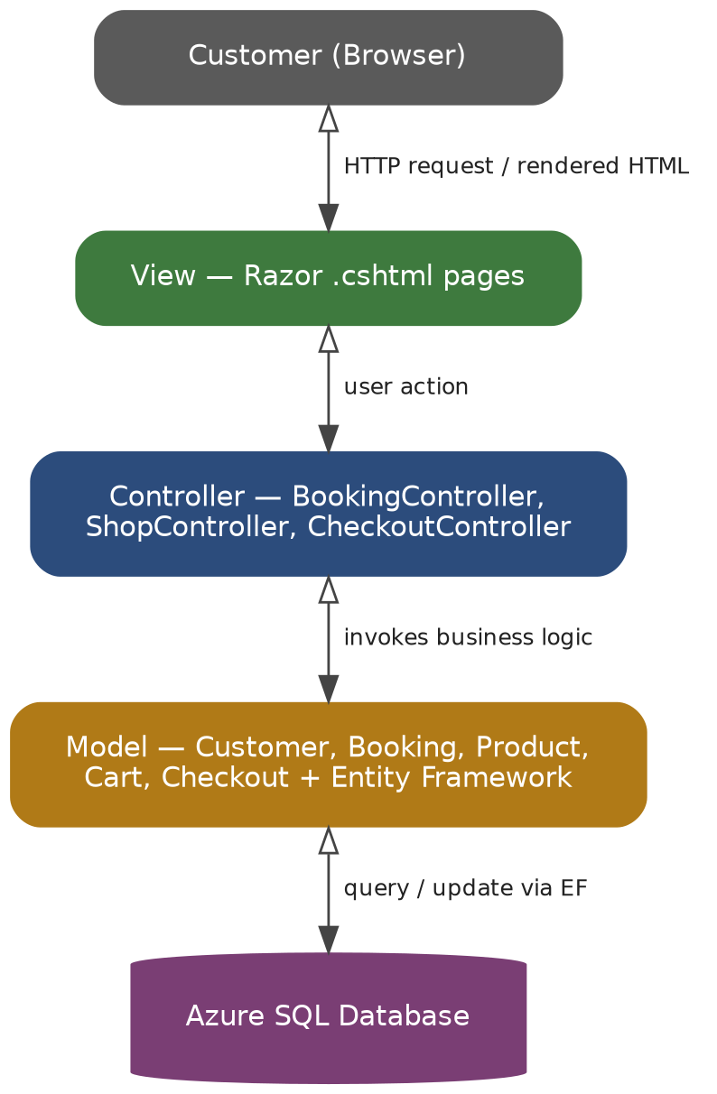
Figure 6: System architecture diagram — MVC layers
Request flow: the customer's browser sends requests to Razor Views, which pass user actions to the relevant Controller (BookingController, TimeSlotController, ReviewController, ShopController, CartController, or CheckoutController). Each Controller invokes the Model layer — the domain classes from Section 4.2 together with Entity Framework — which reads from and writes to the Azure SQL Database. The Controller then selects a View and passes back the data needed to render the response.

7.2.2 Layered (N-Tier) Architecture
The system's overall architecture is proposed as a layered, or N-tier, architecture, structured around a presentation layer, a business logic layer, and a data access layer. This pattern organises a system into horizontal layers, each responsible for a specific concern, with layers communicating vertically such that the presentation layer invokes the business logic layer, which in turn invokes the data access layer (Bui, 2024). This structure improves separation of concerns and renders the application easier to manage, test, and extend, as each layer typically only interacts with the layer directly above or below it (C-Sharp Corner, 2024). Applied to Kinsmen, this results in the following structure: the MVC presentation layer handling user interaction (Figure 6); a business logic layer implementing booking rules, including the design patterns detailed in Section 7.1; and a data access layer, built on Entity Framework Core, interfacing with the Azure SQL Server database.
A layered monolithic architecture is considered appropriate for the current scope of the Kinsmen system, in preference to a distributed or service-oriented approach, on the basis that the system is being developed by a single team, is hosted as a single application on Azure App Service and does not presently require independent scaling of its constituent parts. Should the system's scope expand in future — for example through multi-branch support — this architectural decision would warrant reassessment.

7.3 Cloud Architecture
The Kinsmen system is hosted entirely within a single Azure region, using three managed services: Azure App Service for the application itself, Azure SQL Database for relational data, and Azure Blob Storage for barber and product images (referenced by the PhotoUrl fields in Section 6.2). A single-region, single-instance deployment was chosen deliberately: the system serves one physical branch (per the team's current scope), so the added cost and complexity of multi-region redundancy is not justified at this stage.
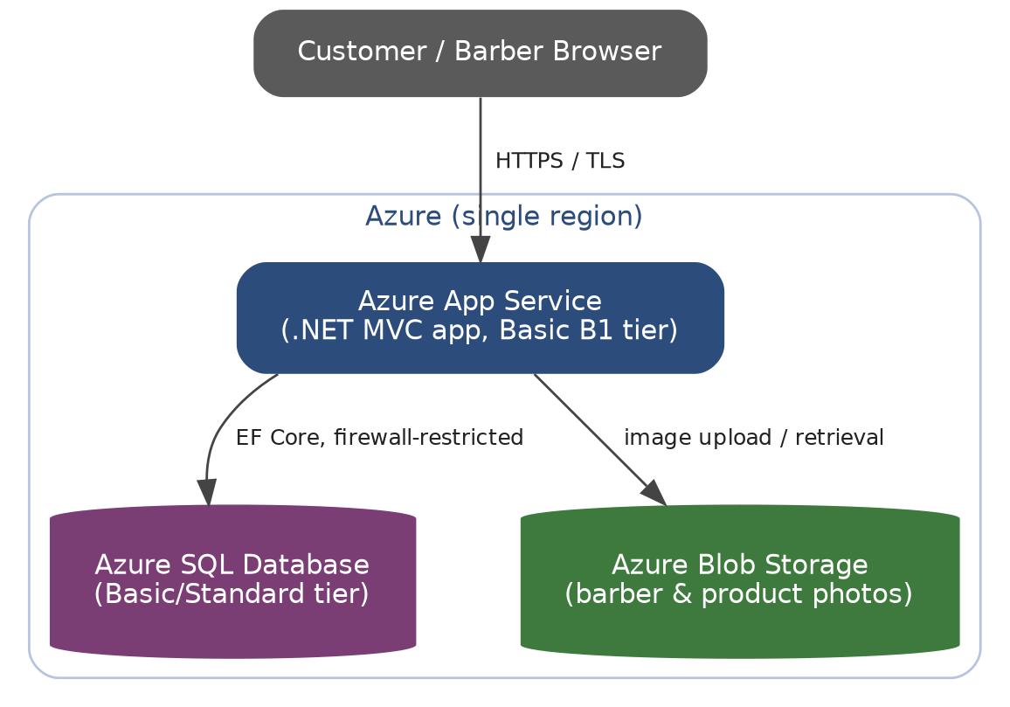
Figure 7: Cloud architecture diagram — Kinsmen booking & shop system
Network segregation: the browser only ever communicates with Azure App Service over HTTPS; Azure SQL Database is not directly reachable from the internet and only accepts connections from the App Service and approved developer IP addresses, per the firewall rules described in Section 8.1.
Protocols: HTTPS/TLS between the browser and App Service; encrypted ADO.NET/TDS connections (via Entity Framework Core) between App Service and Azure SQL Database; HTTPS to Azure Blob Storage for image upload and retrieval.
Tier choice: App Service Basic B1 and Azure SQL Basic/Standard tier were chosen as the minimum tiers that remove the Free tier's CPU-time and custom-domain restrictions, while remaining inexpensive enough for a single-branch shop (see Running Costs).

8. Security
This section outlines how the Kinsmen booking system addresses security across the network, application, and data layers. As the system is hosted on Microsoft Azure using a .NET MVC front end backed by an Azure SQL Server database, the security approach follows standard best practice for this stack, with particular attention to cross-site scripting (XSS) prevention as required by this module.

8.1 Network Security
All traffic between the client browser and the Azure App Service is encrypted using HTTPS/TLS, with HTTP requests automatically redirected to HTTPS. Azure App Service provides a managed TLS certificate for this purpose, removing the need for the team to manage certificates manually.
Access to the Azure SQL Server database is restricted using server-level and database-level firewall rules, allowing connections only from the Azure App Service and approved development IP addresses. Azure SQL Server's built-in threat detection will be used to flag unusual access patterns, such as repeated failed login attempts.
The database connection string, including credentials, is stored in Azure App Service's Application Settings (environment variables) rather than in source-controlled configuration files, so credentials are never committed to GitHub.

8.2 Authentication and Authorisation
ASP.NET Identity (integrated with the .NET MVC framework) will be used to manage user accounts, password hashing, and login sessions. Passwords are never stored in plain text — ASP.NET Identity salts and hashes passwords automatically.
Role-based access control will restrict which actions each user role can perform (for example, distinguishing between customers booking services and Kinsmen staff/admin managing the booking calendar), once user roles are finalised with the client.

8.3 Common Vulnerabilities and Mitigations
SQL Injection: All database access will go through Entity Framework (or equivalent parameterised query approach) rather than concatenated SQL strings, so user input can never be interpreted as executable SQL.
Cross-Site Request Forgery (CSRF): .NET MVC's built-in anti-forgery tokens (@Html.AntiForgeryToken() and the [ValidateAntiForgeryToken] attribute) will be applied to all forms that change data, such as creating or cancelling a booking.
Broken Authentication: Session cookies are marked HttpOnly and Secure, and sessions will time out after a period of inactivity, reducing the risk of session hijacking on shared devices.

8.4 Cross-Site Scripting (XSS) Prevention
The Razor view engine used by .NET MVC HTML-encodes all output by default, meaning any user-supplied text (for example, a customer's name or a booking note) automatically escaped before being rendered, preventing injected scripts from executing in another user's browser.
Where raw HTML output is unavoidable, the team will use explicit encoding or a sanitisation library rather than disabling Razor's automatic encoding.
All user input will be validated server-side (in addition to any client-side validation) using .NET data annotations, so malicious input cannot bypass validation by disabling JavaScript.
A Content Security Policy (CSP) header will be configured to restrict which sources scripts can be loaded from, providing a second layer of defence against XSS even if a malicious script were injected.

8.5 Data Protection
Azure SQL Server provides Transparent Data Encryption (TDE) by default, encrypting data at rest. Combined with HTTPS for data in transit, customer and booking data is encrypted at every stage.
As the current project scope excludes payment gateway integration, PCI-DSS payment card requirements do not apply at this stage; this will be revisited if payment processing is added in a future phase (see Change Management).

8.6 QR Code Implementation
A QR code is planned for the shop's physical signage, linking directly to the Kinsmen booking page. The following placement, sizing, and design guidance was researched to inform this implementation:
Placement: the code should be positioned at eye level on the shop's exterior signage or window, roughly five feet from the ground, since viewing distance affects the required size and position (PageLoot, 2026; Adobe, n.d.).
Sizing: code size should scale with expected scanning distance, following a general industry rule of a 10:1 ratio — for every 10 inches of scanning distance, the code should measure at least 1 inch wide (PageLoot, 2026). As a shopfront code will typically be scanned from one to two metres away, it needs to be considerably larger than the minimum size used for close-range material such as business cards.
Design and contrast: high contrast is essential, with dark colours used for the pattern against a light background, avoiding light colours such as yellow or orange for the code itself (Bitly, 2025). A call to action — "Scan to book your appointment" — should accompany the code, since a code displayed without context rarely prompts a scan; a clear call-to-action can increase scan rates by up to 52% (PageLoot, 2026).
Static vs dynamic: a dynamic QR code is recommended, as it uses a modifiable short URL to redirect to the current landing page without requiring the printed code to be replaced (Supercode, 2026). Since the booking site's final URL structure may change prior to or shortly after launch, this avoids the need to reprint signage and additionally allows the team to track shopfront scan volume as a simple client engagement metric (QRNow, 2025).
Recommendation: implement a dynamic QR code, sized for street-viewing distance, positioned at eye level on the shop window or door, printed in high contrast, and accompanied by a short call-to-action linking directly to the booking page rather than a general homepage.

8.7 Biometric Authentication (Future Consideration)
Biometric functionality is flagged as a future consideration for the Kinsmen system, pending client confirmation, and is not built into the current implementation scope. Two materially different approaches were assessed:
Option A — Server-side biometric hardware: dedicated fingerprint, face, or iris scanners integrated via a vendor SDK, with biometric templates stored in the cloud (M2SYS, 2022). This carries hardware procurement costs, ongoing licensing, and a substantially increased data protection burden, none of which is proportionate to a single-branch barber booking system. This option is not recommended.
Option B — Browser-based biometrics via WebAuthn (recommended if pursued): device-based authentication that performs the biometric check locally on the user's device rather than on Kinsmen's servers. The user's device holds a private key and the server stores only the corresponding public key; at login, the device signs a server-issued challenge following biometric or PIN verification (Authgear, 2026), with phishing resistance following directly from this design (MDN, 2026). ASP.NET Core Identity — the authentication framework already confirmed for this project (see Section 8.2) — provides native support for passkey registration and authentication, positioning this as a relatively low-effort future addition (Microsoft Learn, n.d.-a).
Data protection rationale: server-side storage of raw biometric data should be avoided regardless of approach, since a compromised biometric credential cannot be reset the way, a password can (IdentityServer.com, 2024). This favours Option B on data protection grounds alone.
Recommendation: document biometric functionality as feasible only via WebAuthn/passkey (device-based) authentication, excluding dedicated biometric hardware on cost, compliance, and scope grounds. Retain as a documented future consideration pending client confirmation.

9. DevOps
Rapid, reliable deployment is central to the success of the Kinsmen booking system, particularly given the team's tight timeline across Tasks 1 to 3. The team has adopted a GitHub-based workflow built around a single protected main branch, individual feature branches, and an automated GitHub Actions pipeline covering both continuous integration (CI) and continuous deployment (CD).

9.1 Branching Strategy and Development Flow
main branch — always reflects a stable, deployable state of the application. Direct commits to main are not permitted.
feature/* branches — each team member develops their assigned work (e.g. feature/backend, feature/frontend) in an isolated branch, preventing incomplete or breaking changes from affecting the rest of the team.
Pull Requests (PRs) — once a feature is complete, the owning team member opens a PR targeting main. This triggers the CI pipeline automatically.
Code review — at least one other team member reviews and approves the PR before it can be merged, catching issues early and spreading knowledge of the codebase across the team.
Merge — once approved and passing all automated checks, the PR is merged into main, which automatically triggers the CD pipeline.

9.2 Automated Testing
Automated testing is integrated directly into the CI stage of the pipeline. On every pull request, GitHub Actions restores dependencies, builds the solution, and runs the project's xUnit test suite (covering booking logic, service selection, and API endpoints). A pull request cannot be merged if the build fails or any test does not pass, ensuring that broken code never reaches main.

9.3 GitHub Actions Pipeline
The diagram below illustrates the full pipeline, from an individual feature branch through to a live deployment on Azure.
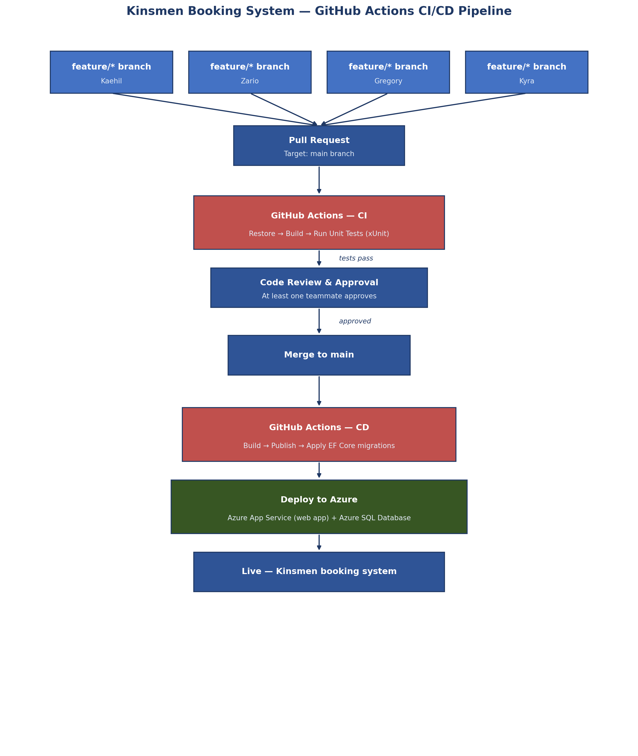
Figure 8: GitHub Actions CI/CD Pipeline — Kinsmen booking system
As shown above, code changes move through four automated stages: pull request creation, continuous integration (build and test), a human code review gate, and continuous deployment (build, publish, and deploy to Azure). Database schema changes are applied automatically as part of the CD stage using Entity Framework Core migrations, keeping the Azure SQL Database schema in sync with the codebase without manual intervention.

10. Running Costs
Costs below are estimated in USD, based on Azure's published pay-as-you-go pricing for the App Service and Azure SQL Database tiers described in Section 7.3 (approximate ZAR figures shown for reference, at roughly R18.5/USD; actual billing will be in the currency of the Azure subscription). As agreed in Section 6, there is no payment gateway in the current scope — shop purchases are settled in person — so no transaction-based payment processing fees apply.

10.1 Monthly Running Costs (Current Scale)
Item | Tier | Est. Monthly Cost (USD) | Est. Monthly Cost (ZAR)
Azure App Service | Basic B1 | ~$13.14 | ~R243
Azure SQL Database | Basic (5 DTU, 2GB) | ~$4.90 | ~R91
Azure Blob Storage | Hot tier, <5GB images | ~$0.50 | ~R9
Email notifications | Free tier (e.g. SendGrid, ~100/day) | $0.00 | R0
Domain & TLS certificate | App Service-managed | $0.00 | R0
Total (current scale) |  | ~$18.54 | ~R343
Note: The Azure Free tier (F1 App Service, and Azure SQL's free monthly allowance) could reduce this to near $0 during early development but is not suitable for the live system due to the 60 CPU minute/day cap and lack of a custom domain on App Service's Free tier.

10.2 Cost at Scale
The table below projects costs as the customer base grows, assuming the first 100 users are covered by the current-scale tiers above, with tier upgrades applied as traffic increases.
Users | App Service Tier | SQL Tier | Est. Monthly Cost (USD)
100 | Basic B1 | Basic (5 DTU) | ~$18.54 (as above)
1,000 | Standard S1 (autoscale) | Standard S0 (10 DTU) | ~$72
10,000 | Standard S2 (autoscale, 2+ instances) | Standard S2 (50 DTU) | ~$260+
These figures are estimates based on published Azure pricing at the time of writing and will be refined once real usage data is available; Azure Advisor and Cost Management budget alerts will be configured once the system is live, so the team is notified before costs exceed expected levels.

10.3 Two-Year Growth Projection
Assuming steady adoption growth (a realistic pattern for a single-branch local business rather than a viral consumer app), the system is expected to remain within the 100–1,000 user range through Year 1, with the Standard tier upgrade in Year 2 as the customer base and product catalogue grow. Based on this, running costs are projected at approximately $220–260/year in Year 1 (Basic tier) and approximately $700–900/year in Year 2 (Standard tier), excluding any WhatsApp notification costs should that channel be added (see Section 7.1.4).

11. Change Management

11.1 Organisational Adoption
Why: Kinsmen currently manage bookings manually, which limits schedule visibility and makes it difficult to track which services and products are most popular. The new system gives barbers and management a live view of the day's bookings and removes manual double-booking risk (via the TimeSlot validation described in Section 6.2).
How: barbers will be onboarded with a short, hands-on training session covering the barber-facing schedule view and how to mark time slots as blocked (e.g. for breaks). Management will be trained separately on the admin views for managing services, products, and stock levels.

11.2 Customer Adoption
Why: customers benefit from being able to book at any time, see real barber availability, and browse shop products before arriving — rather than needing to call or visit in person.
How: in-store signage featuring the QR code described in Section 8.6 will direct existing walk-in customers to the new booking page. Barbers will also be briefed to mention the new system to customers during appointments in the weeks after launch.

11.3 Handover and Transition Timeline
Weeks 1–2 post-launch: parallel running — the system goes live for customer bookings, while staff continue to keep a manual backup schedule as a safety net.
Weeks 3–4: full transition — manual scheduling is retired once staff confirm confidence in the system; the team remains on-call to fix any issues quickly during this period.
Ongoing: the team hands over basic system administration (adding/removing services and products, viewing bookings) to Kinsmen management, with documentation provided via the Task 3 User Guide.

11.4 Future Enhancements
Two features were discussed by the team but are intentionally excluded from the current scope, to keep Task 1 realistic and achievable:
Loyalty/points system: flagged during early planning as a potential future enhancement to reward repeat customers. Not included in the current domain model (Section 4) or ERD (Section 6), and would require client confirmation before being scoped into a future phase.
Biometric authentication: as discussed in Section 8.7, feasible only via WebAuthn/passkey (device-based) authentication in a future phase, pending client interest — not part of the current implementation.

12. Prototype
The following is a link to the prototype hosted using GitHub pages

12.1. GitHub pages hyperlink
https://kaehil-i.github.io/kinsmen-barbershop/kinsmen_prototype.html

References
Adobe (n.d.) QR code design best practices. Available at: https://www.adobe.com/express/discover/qr-code-design-best-practices (Accessed: 3 August 2026).
Authgear (2026) How to implement passkeys with WebAuthn: developer guide. Available at: https://www.authgear.com/post/how-to-implement-passkeys-developer-guide/ (Accessed: 3 August 2026).
Bitly (2025) 8 best practices for QR code design. Available at: https://www.the-qrcode-generator.com/blog/qr-code-best-practices (Accessed: 3 August 2026).
Bui, L. (2024) Layered (N-tier) architecture. Available at: https://blog.longbui.net/layered-pattern (Accessed: 31 July 2026).
C-Sharp Corner (2024) Layered (N-tier) architecture in .NET Core. Available at: https://www.c-sharpcorner.com/blogs/layered-ntier-architecture-in-net-core (Accessed: 31 July 2026).
Dot Net Tutorials (2023) Real-time examples of observer design pattern in C#. Available at: https://dotnettutorials.net/lesson/real-time-examples-of-observer-design-pattern-in-csharp/ (Accessed: 31 July 2026).
EmbeddedHow (2023) Strategy: must know design pattern (6/7). Available at: https://www.embeddedhow.com/post/strategy-must-know-design-pattern-6-7 (Accessed: 31 July 2026).
Ghosh, R. (2024) Understanding ASP.NET MVC: an overview, Medium. Available at: https://medium.com/@rubenghosh968/understanding-asp-net-mvc-an-overview-7168ce7b912a (Accessed: 31 July 2026).
IdentityServer.com (2024) Using biometrics in ASP.NET Core. Available at: https://www.identityserver.com/articles/using-biometrics-in-aspnet-core (Accessed: 3 August 2026).
M2SYS (2022) Award winning biometric SDK for asp.net application. Available at: https://www.m2sys.com/blog/biometric-software/award-winning-biometric-sdk-for-asp-net-application/ (Accessed: 3 August 2026).
MDN (2026) Web Authentication API. Available at: https://developer.mozilla.org/en-US/docs/Web/API/Web_Authentication_API (Accessed: 3 August 2026).
Microsoft (n.d.) ASP.NET MVC pattern. Available at: https://dotnet.microsoft.com/en-us/apps/aspnet/mvc (Accessed: 31 July 2026).
Microsoft Learn (n.d.-a) Enable Web Authentication API (WebAuthn) passkeys. Available at: https://learn.microsoft.com/en-us/aspnet/core/security/authentication/passkeys/?view=aspnetcore-10.0 (Accessed: 3 August 2026).
Microsoft Learn (n.d.-b) Implementing the infrastructure persistence layer with Entity Framework Core. Available at: https://learn.microsoft.com/en-us/dotnet/architecture/microservices/microservice-ddd-cqrs-patterns/infrastructure-persistence-layer-implementation-entity-framework-core (Accessed: 31 July 2026).
PageLoot (2026) Guidelines for placing QR codes on marketing materials. Available at: https://pageloot.com/blog/ultimate-guide-to-qr-code-placement-in-marketing/ (Accessed: 3 August 2026).
QRNow (2025) Static vs. dynamic QR code: what's the difference? Available at: https://www.qrnow.com/blog/static-vs-dynamic-qr-codes (Accessed: 3 August 2026).
Sebastiandevelops (2025) Understanding the factory design pattern in C# with real-world examples, DEV Community. Available at: https://dev.to/sebastiandevelops/understanding-the-factory-design-pattern-in-c-with-real-world-examples-b1b (Accessed: 31 July 2026).
Supercode (2026) Dynamic vs. static QR codes: 2026 guide. Available at: https://www.supercode.com/blog/dynamic-vs-static-qr-codes (Accessed: 3 August 2026).
Uslu, M. (2025) Understanding the repository pattern in .NET Core, Medium. Available at: https://mcuslu.medium.com/understanding-the-repository-pattern-in-net-core-0818bbcdaf03 (Accessed: 31 July 2026).

Appendices

Annexure A – Declaration of Authenticity
I, Zario Di Paolo, ID Number: 0606045377086, hereby declare that this portfolio, and any evidence included therein, contains my own independent work and that I have not received help from other groups. I confirm that we have not committed plagiarism in the accomplishment of this work, nor have I falsified and/or invented experimental data. I accept the academic penalties that may be imposed for violations of the above.
STUDENT NUMBER: ST10441349
STUDENT NAME: Zario Di Paolo
STUDENT SIGNATURE: ____________________________ DATE: __17 August 2026__

I, Kaehil Indurjeeth, ID Number: 0511105258087, hereby declare that this portfolio, and any evidence included therein, contains my own independent work and that I have not received help from other groups. I confirm that we have not committed plagiarism in the accomplishment of this work, nor have I falsified and/or invented experimental data. I accept the academic penalties that may be imposed for violations of the above.
STUDENT NUMBER: ST10438880
STUDENT NAME: Kaehil Indurjeeth
STUDENT SIGNATURE: ____________________________ DATE: __17 August 2026__

I, Kyra Naidoo, ID Number: 0306210096088, hereby declare that this portfolio, and any evidence included therein, contains my own independent work and that I have not received help from other groups. I confirm that we have not committed plagiarism in the accomplishment of this work, nor have I falsified and/or invented experimental data. I accept the academic penalties that may be imposed for violations of the above.
STUDENT NUMBER: ST10448414
STUDENT NAME: Kyra Naidoo
STUDENT SIGNATURE: ____________________________ DATE: __17 August 2026__

I, Gregory Luyckfasseel, ID Number: 051031, hereby declare that this portfolio, and any evidence included therein, contains my own independent work and that I have not received help from other groups. I confirm that we have not committed plagiarism in the accomplishment of this work, nor have I falsified and/or invented experimental data. I accept the academic penalties that may be imposed for violations of the above.
STUDENT NUMBER: ST10441344
STUDENT NAME: Gregory Luyckfasseel
STUDENT SIGNATURE: ____________________________ DATE: __17 August 2026__

